DOE – 001 – Camera Drift

This experiment is to determine if the temperature reading will drift from cold start to warm camera sensor over time. And to determine if it is necessary to monitor the internal temperature of the FPA.

Setup:

- Black body source powered up and at temperature for 1 hour @ 37C
- Camera placed on tripod and aimed at source
- Start camera cold and allow to warm up for several hours while tracking raw ADC values from the center pixel.

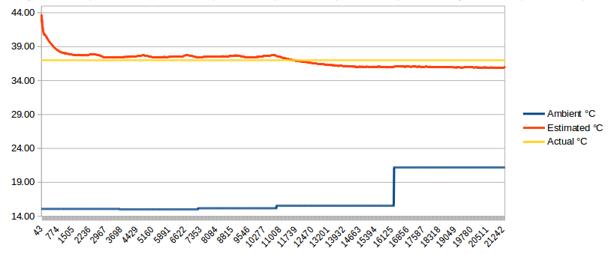
X:Time in seconds
Y: Deg C

Estimated =sample[n] / (average(raw) / 37)

Conclusion:

- Camera takes about 1 hour to stabilize. We will need to work on calibration for that first hour. It wouldn't be much use if we have to turn it on and then wait an hour to start capturing data.
- Camera is sensitive to changes in ambient temperature. You can see bumps in the data every time I entered the room making it cooler.
- Reading the on board temperature sensor is an absolute must. The internal temperature sensor has an accuracy of ±5° as per the data sheet (page:57). This would appear to be the limiting factor in achieving maximum accuracy. It isn’t currently clear how the overall sensor temperature effects final accuracy.

